COGNITIVE, SUBSTANCE-RELATED, SCHIZOPRENIA, AND OTHER PSYCHOTIC DISODERS

COGNITIVE DISORDERS

In early editions of the DSM, they were labeled “organic mental disorders,” along with mood, anxiety, personality, hallucinosis (an abnormal mental state involving hallucinations), and delusional disorders

- The label “cognitive disorders” was used in DSM-IV to signify that their predominant feature is the impairment of such cognitive abilities as memory, attention, perception, and thinking.
- In DSM-5, neurocognitive disorders is the new category name for the various forms of dementia and amnestic disorders, with “major” or “mild” subtypes; DSM-5 retains the “delirium” label.
- Two classes of cognitive disorders: delirium and mild or major neurocognitive disorder.

Delirium

- Temporary state of confusion and disorientation that can be caused by brain trauma, intoxication by drugs or poisons, surgery, and a variety of other stressful conditions.
- Cannot focus and sustain their attention on even the simplest tasks.
- Marked impairments in memory and language
- Acute onset
- 50% of people with dementia suffer at least one episode of delirium
- Age itself is an important factor; older adults are more susceptible to developing delirium
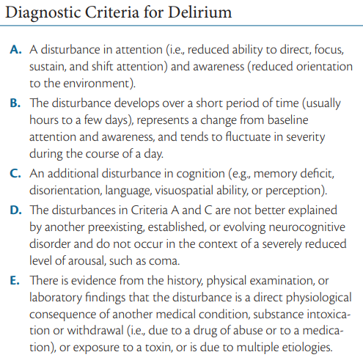

Treatments
- Address underlying causes
- Delirium brought on by withdrawal from alcohol or other drugs is usually treated with antipsychotic medications, which help calm the individual.
- Psychosocial intervention: to reassure the individual to help him or her deal with the agitation, anxiety, and hallucinations of delirium
- The presence of a family member and familiar personal belongings such as family photographs may also be an easy and comforting intervention.
- Managed care and patient counseling can play significant roles in preventing delirium.

MAJOR AND NEUROCOGNITIVE DISORDERS

- Major neurocognitive disorder (previously labeled dementia) is a gradual deterioration of brain functioning that affects memory, judgment, language, and other advanced cognitive processes.
- Mild neurocognitive disorder is a new DSM-5 disorder that was created to focus attention on the early stages of cognitive decline.
- Agnosia - the inability to recognize and name objects, is one of the most familiar symptoms
- Facial agnosia (prosopagnosia) - the inability to recognize even familiar faces.

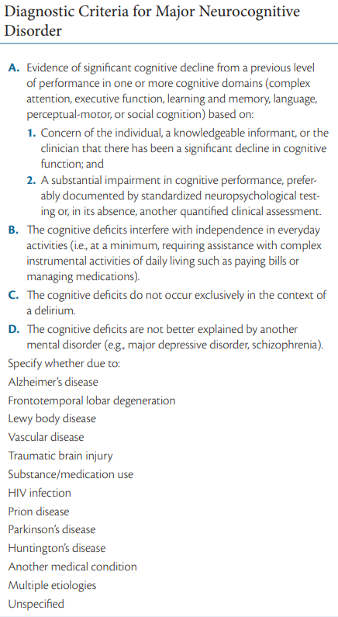

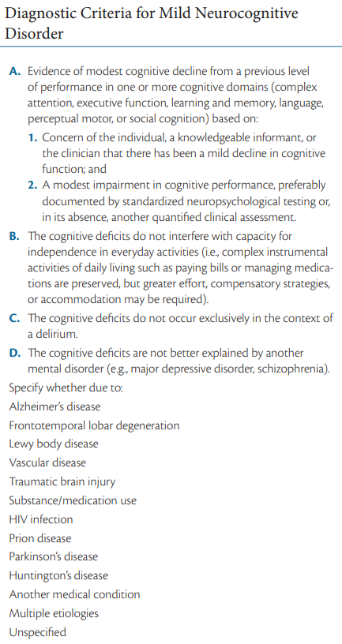

CLASSES OF NEUROCOGNITIVE DISORDERS BASED ON ETIOLOGY

i. Alzheimer’s Disease
ii. Vascular Injury/ Neurocognitive Disorder
iii. Frontotemporal Degeneration
iv. Traumatic Brain Injury
v. Lewy Body Disease
vi. Parkinson’s Disease
vii. HIV Infection
viii. Substance Use
ix. Huntington’s Disease
x. Prion Disease
xii. Another Medical Condition

i. Alzheimer’s Disease

- Most common type of neurocognitive disorder, named after the German psychiatrist Alois Alzheimer
- first described as a “strange disease of the cerebral cortex”
- Symptoms:
  - impairment of memory
  - orientation
  - judgment and reasoning.
  - the inability to integrate new information results in failure to learn new associations
  - tend to lose interest in others and, as a result, become more socially isolated.
- As the disorder progresses, they can become agitated, confused, depressed, anxious, or even combative.
- Aphasia - difficulty with language
- Apraxia - impaired motor functioning
- Agnosia - failure to recognize objects
- Cognitive impairments have a serious negative impact on social and occupational functioning..
- It is the leading cause of neurocognitive disorder.
- Common onset: ≈ 60s or 70s
- Early onset: ≈ 40s or 50s
- Approximately 50% of the cases of neurocognitive disorder are found to be the result of Alzheimer’s disease.
- Prevalent among women

ii. Vascular Neurocognitive Disorder

- It is a progressive brain disorder that is one of the more common causes of neurocognitive deficits.
- Vascular refers to blood vessels; neurocognitive disorder that is a result of stroke.
- Cognitive disturbances such as declines in speed of information processing and executive functioning (e.g., complex decision-making)
- More sudden onset than Alzheimer’s disease
- Statistics: approximately 1.5% in people 70 to 75 years of age and increases to 15% for those over the age of 80
- Slightly higher risk for men than women

iii. Frontotemporal Neurocognitive Disorder

- It is a term used to categorize a variety of brain disorders that damage the frontal or temporal regions of the brain areas that affect personality, language, and behavior.
- Declines in appropriate behavior (e.g., socially inappropriate actions, apathy, making poor judgments) or language (e.g., problems with speech, finding the right word, naming objects)
- Approximately 20%–25% of cases of frontotemporal NCD occur in individuals older than 65 years

iv. Traumatic Brain Injury

- It includes symptoms that persist for at least a week following the trauma, including executive dysfunction (e.g., difficulty planning complex activities) and problems with learning and memory
- Greatest risk for TBI are teens and young adults
- Traffic/vehicular accidents, assaults, falls, and suicide attempts are common causes, as is being exposed to bomb blasts in combat.

v. Lewy Body Disease

- It is the second most common type of neurocognitive disorder (after Alzheimer’s disease).
- Lewy bodies are microscopic deposits of a protein that damage brain cells over time.
- The signs of this disorder come on gradually and include impairment in alertness and attention, vivid visual hallucinations, and motor impairment.
- The male-to-female ratio is approximately 1.5:1.

vi. Parkinson’s Disease

- Result of damage to dopamine pathways.
- Motor problems are characteristic among people with Parkinson’s disease, who tend to have stooped posture, slow body movements (called bradykinesia), tremors, and jerkiness in walking, afflicted individuals speak in a soft monotone.
- A degenerative brain disorder that affects about 100 to 300 people in every 100,000 people worldwide.
- more common in males than in females.

vii. Human Immunodeficiency Virus Type 1

- Also referred to as subcortical dementia, because it affects the cortex.
- Caused by HIV infection itself
- Early symptoms:
  - cognitive slowness,
  - impaired attention, and forgetfulness.
  - Affected individuals also tend to be clumsy, show tremors and leg weakness, and become apathetic and socially withdrawn.
- Likely to experience severe depression and anxiety.
- ≈ 25% of individuals with HIV will have signs and symptoms that meet criteria for mild NCD

viii. Substance/Medication Induced Neurocognitive Disorder

- 50% to 70% of chronic heavy alcohol users show cognitive impairment
- Symptoms include memory impairment and at least one of the following cognitive disturbances:
  - aphasia (language disturbance),
  - apraxia (inability to carry out motor activities despite intact motor function)
  - agnosia (failure to recognize or identify objects despite intact sensory function), or a disturbance in executive functioning (such as planning, organizing, sequencing, and abstracting)

viii. Huntington’s Disease

- genetic disorder that initially affects motor movements (e.g., impaired gait), typically in the form of chorea, involuntary limb movements.
- 42.5% of new Huntington’s disorder cases also present with mild cognitive impairment
- worldwide prevalence of ≈2.7 per 100,000

ix. Prion Disease

- rare progressive neurodegenerative disorder caused by “prions”—proteins that can reproduce themselves and cause damage to brain cells leading to neurocognitive decline
- Ataxia – impaired gait

SUBSTANCE-RELATED DISORDERS

- It is associated with the abuse of drugs and other substances people take to alter the way they think, feel, and behave.
- 9.7% of the general population (12 years or older) are believed to use illegal drugs.
- Substance refers to chemical compounds that are ingested to alter mood or behavior.
- Substance intoxication refers to the undesirable behavioral or psychological changes that develop during or shortly after the ingestion of a substance; includes the type of drug taken, the amount ingested, and the person’s individual biological reaction.
- Substance dependence refers to the maladaptive pattern of substance use characterized by the need for increased amounts to achieve the desired effect, negative physical effects when the substance is withdrawn, unsuccessful efforts to control its use, and substantial effort expended to seek it or recover from its effects.
- Tolerance is the brain and body’s need for larger doses of a drug to produce earlier effects.
- Withdrawal is the negative physical response when the substance is no longer ingested. Withdrawal from many substances can bring on chills, fever, diarrhea, nausea and vomiting, and aches and pains.

Categories of Substance-Related Disorders

- Depressants: These substances result in behavioral sedation and can induce relaxation. They include alcohol, barbiturates, and benzodiazepines
- Stimulants: These substances cause us to be more active and alert and can elevate mood. Included in this group are amphetamines, cocaine, nicotine, and caffeine
- Opiates: The major effect of these substances is to produce analgesia temporarily (reduce pain) and euphoria. Heroin, opium, codeine, and morphine are included in this group.
- Hallucinogens: These substances alter sensory perception and can produce delusions, paranoia, and hallucinations. Cannabis and LSD are included in this category.
- Other drugs of abuse: includes inhalants, anabolic steroids, and other over-the-counter and prescription medications.

Alcohol-Related Disorders

- Impaired judgment and motor coordination (staggering, slurred speech), reaction time is slowed, confused, and even vision and hearing can be negatively affected.
- Withdrawal from chronic alcohol use typically includes hand tremors, nausea or vomiting, anxiety, transient hallucinations, agitation, insomnia, and delirium tremens, conditions that can produce frightening hallucinations and body tremors.
- Wernicke-Korsakoff syndrome - results in confusion, loss of muscle coordination, and unintelligible speech. It is caused by a deficiency of thiamine, a vitamin metabolized poorly by heavy drinkers.
- Fetal alcohol syndrome (FAS) - includes fetal growth retardation, cognitive deficits, behavior problems, and learning difficulties.
- Physical characteristics of children with FAS include skin folds at the corners of the eyes, low nasal bridge, short nose, no groove between nose and upper lip, small head circumference, small eye opening, small midface, and thin upper lip.
- Lifetime prevalence of 29%

Stages of Alcohol use (Jellinek, 1952):
- prealcoholic stage - drinking occasionally with few serious consequences
- prodromal stage - drinking heavily but with few outward signs of a problem
- crucial stage - loss of control, with occasional binges
- chronic stage - the primary daily activities involve getting and drinking alcohol

Sedative-, Hypnotic-, Anxiolytic-Related Disorders

- sedative (calming)
- hypnotic (sleep-inducing)
- anxiolytic (anxiety-reducing) drugs
- Barbiturates - prescribed to help people sleep and replace such drugs as alcohol and opium
- Benzodiazepines - primarily to reduce anxiety muscle relaxants
- Overdosing on barbiturates is a common means of suicide
- Females are more likely to seek help than men

Stimulant-Related Disorders

Amphetamines
- Can induce feelings of elation and vigor and can reduce fatigue; after a period of elevation, however, you come back down and “crash,” feeling depressed or tired; also reduce appetite
- Prescribed for people with narcolepsy and ADHD (e.g., Ritalin, Adderall)

Methylene-dioxymethamphetamine (MDMA)
- commonly known as ecstasy is used as an appetite suppressant but is now often used as a club drug.
- Methamphetamine (a.k.a “crystal meth” or “ice”) – a purified, crystallized form of amphetamine; ingested through smoking; this drug causes marked aggressive tendencies and stays in the system longer than cocaine, making it particularly dangerous.

↑ amphetamine = ↑ dopamine and norepinephrine → hallucinations and delusions

Amphetamines stimulate the central nervous system by enhancing the activity of norepinephrine and dopamine.

Cocaine
- relief from hunger and fatigue
- increases alertness, produces euphoria, increases blood pressure and pulse, and causes insomnia and loss of appetite
- Worldwide, almost 5% of adults report using cocaine at some point in their lives.
- Those aged 18 to 25 are about twice as likely to use cocaine compared with other age groups.
- Men are twice as likely to use cocaine as women.
- The “up” seems to come primarily from the effect of cocaine on the dopamine system. This stimulation of the dopamine neurons in the “pleasure pathway” causes the high associated with cocaine use.

Nicotine
- Withdrawal symptoms include depressed mood, insomnia, irritability, anxiety, difficulty concentrating, restlessness, and increased appetite and weight gain
- Only 7 to 19 seconds after a person inhales the smoke, the nicotine reaches the brain
- Smoking has been linked with signs of negative affect, such as depression, anxiety, and anger.
- Genetic studies suggest that a genetic vulnerability combined with certain life stresses may combine to make you vulnerable to both a nicotine use disorder and depression

Caffeine
- It is the most common of the psychoactive substances
- Called the “gentle stimulant” because it is thought to be the least harmful of all addictive drugs
- Found in tea, coffee, many soda drinks, and cocoa products.
- Caffeine seems to block adenosine reuptake. Adenosine plays an important role in the release of dopamine and glutamate, which may explain the elation and increased energy that come with caffeine use.

Opioids-Related Disorders

- Opiate refers to the natural chemicals that have a narcotic effect - relieve pain and induce sleep.
- Opioids refers to the family of substances that includes natural opiates, synthetic variations (heroin, methadone, hydrocodone, oxycodone)
- Persistence opioid use may be related to comorbid psychological disorders and sexual or physical abuse

Hallucinogen-Related Disorders

- LSD (d-lysergic acid diethylamide), sometimes referred to as “acid,” is the most common hallucinogenic drug
- Psilocybin is found in certain species of mushrooms
- Perceptual changes such as the subjective intensification of perceptions, depersonalization, and hallucinations.
- Physical symptoms include pupillary dilation, rapid heartbeat, sweating, and blurred vision
- People do report having “bad trips”; these are the sort of frightening episodes in which clouds turn into threatening monsters or deep feelings of paranoia take over

Cannabis
- Marijuana is the name given to the dried parts of the cannabis or hemp plant; aka “weed.”
- People who smoke marijuana often experience altered perceptions of the world and are believed to alter mood and behavior.
- Normal experiences seem extremely funny, or the person might enter a dreamlike state in which time seems to stand still. Users often report heightened sensory experiences and seeing vivid colors
- Research on frequent cannabis users suggests that impairments of memory, concentration, relationships with others, and employment may be negative outcomes of long-term use

Other drugs of abuse

Inhalants
- Include a variety of substances found in volatile solvents—making them available to breathe into the lungs directly
- Inhalant use is highest during early adolescence, ages 13 to 14
- Can increase aggressive and antisocial behavior

Steroids
- The legitimate medical uses of these drugs focus on people with asthma, anemia, breast cancer, and males with inadequate sexual development.
- Used to enhance performance and body size
Other Medications

GAMBLING DISORDERS

Studies have found that the ventromedial prefrontal cortex and orbitofrontal cortex do not function as normal in those with gambling disorders. Poor impulse control and risky decisions are both processes that involve ventromedial prefrontal cortex and those individuals with higher problems in these areas also show poorer response to treatment and higher relapse rates.
- Characteristics: denial of the problem, impulsivity, and continuing optimism (“One big win will cover my losses!”)

Impulse-control Disorder

Intermittent Explosive Disorder
- Have episodes in which they act on aggressive impulses that result in serious assaults or destruction of property.
- Lifetime prevalence of 7.3%
- Recent studies have proposed that there is a disruption of the orbital frontal cortex in inhibiting amygdala activation combined with changes in the serotonin system in those with this disorder.

Kleptomania
- A recurrent failure to resist urges to steal things that are not needed for personal use or their monetary value
- More common in women than in men and that it typically starts in adolescence
- People with kleptomania score high on assessments of impulsivity, reflecting their inability to judge the immediate gratification of stealing compared with the long-term negative consequences.
- Patients with kleptomania often report having no memory (amnesia) about the act of shoplifting.
Pyromania
- Involves being preoccupied with fires and the associated equipment involved in setting and putting out these fires.
- Pyromania is diagnosed in only about 3% of arsonists
- Treatment is cognitive-behavioral and involves helping the person identify the signals that initiate the urges and teaching coping strategies to resist the temptation to start fires.

SCHIZOPHRENIA

Characterized by a broad spectrum of cognitive and emotional dysfunctions including delusions and hallucinations, disorganized speech and behavior, and inappropriate emotions
- Eugen Bleuler coined the term schizophrenia, which comes from the combination of the Greek words for “split” (skhizein) and “mind” (phren)

4 A’s of Schizophrenia:
(1) affective disturbance
(2) ambivalence
(3) autism
(4) disturbance of thought association

Diagnosis of schizophrenia requires that two or more positive, negative, and/or disorganized symptoms be present for at least 1 month, with at least one of these symptoms including delusions, hallucinations, or disorganized speech.
Severity of symptoms:
0 - symptom is not present
1 - equivocal evidence (i.e., not sure)
2 - present but mild
3 - present and moderate
4 - present and severe

Phases of Schizophrenia

- Premorbid - individual’s functioning prior to the disorder
- Prodromal - a 1 to 2-year period before the serious symptoms occur but when less severe yet unusual behaviors start to show themselves such as ideas of reference and magical thinking
- Active – a.k.a “onset phase”, positive, negative or disorganized symptoms are “full-blown”
- Residual – periods of remission, could be partial or complete.

Positive Symptoms

- Delusions
  - Delusion of grandeur - a mistaken belief that the person is famous or powerful
  - Delusion of persecution - others are “out to get them.”
  - Capgras syndrome - the person believes someone he or she knows has been replaced by a double
  - Cotard’s syndrome - the person believes he or she is dead
  - Motivational view - beliefs are attempts to deal with and relieve anxiety and stress.
  - Deficit view - sees these beliefs as resulting from brain dysfunction that creates these disordered cognitions or perception.
- Hallucinations
  - Experience of sensory events without any input from the surrounding environment
  - Auditory hallucination is the most common form experienced by people with schizophrenia
  - People who experience hallucinations appear to have intrusive thoughts, but they believe they are coming from somewhere or someone else
  - Broca’s area – part of the brain most active during hallucinations; is known to be involved in speech production
  - Wernicke’s area – involves in language comprehension; people who are hallucinating are not hearing the voices of others but are listening to their own thoughts or their own voices and cannot recognize the difference

Negative Symptoms

- Avolition is the inability to initiate and persist in activities; people with this symptom show little interest in performing even the most basic day-to-day functions, including those associated with personal hygiene.
- Alogia refers to the relative absence of speech
- Anhedonia is the presumed lack of pleasure
- Asociality refers to the lack of interest in social interaction
- Affective Flattening is a symptom wherein individuals do not show emotions when you would normally expect them to.

Disorganized Symptoms

These include a variety of erratic behaviors that affect speech, motor behavior, and emotional reactions:
- Disorganized Speech - people with schizophrenia often lack insight and awareness that they have a problem.
- Tangentiality - going off on a tangent instead of answering a specific question.
- Loose association or derailment - abruptly changes the topic of conversation to unrelated areas
- Inappropriate affect - laughing or crying at improper times.
- Disorganized behavior - exhibit bizarre behaviors in public
- Catatonic immobility - people hold unusual postures, as if they were fearful of something terrible happening if they moved
- Waxy flexibility - the tendency to keep their bodies and limbs in the position they are put in by someone else

OTHER PSYCHOTIC DISORDERS

Schizophreniform Disorder

Lifetime prevalence is approximately 0.2%

The diagnostic criteria includes onset of psychotic symptoms within 4 weeks of the first noticeable change in usual behavior, confusion at the height of the psychotic episode, good premorbid (before the psychotic episode) social and occupational functioning, and the absence of blunted or flat affect.

Schizoaffective Disorder

DSM-5 criteria for schizoaffective disorder require, in addition to the presence of a mood disorder, delusions or hallucinations for at least 2 weeks in the absence of prominent mood symptoms

The prognosis is that individuals tend not to get better on their own and are likely to continue experiencing major life difficulties for many years.

Delusional Disorder

- Persistent belief that is contrary to reality, in the absence of other characteristics of schizophrenia; they may become socially isolated because they are suspicious of others.
- The delusions are often long-standing, sometimes persisting over several years.
- In delusional disorder, the imagined events could be happening but aren’t (e.g., mistakenly believing you are being followed); In schizophrenia, imagined events are outside the realm of possibility.
- Shared psychotic disorder (folie à deux) is the condition in which an individual develops delusions simply as a result of a close relationship with a delusional individual.
- Delusional disorder seems to afflict more females than males (55% and 45%, respectively, of the affected population).
- A number of other disorders can cause delusions, and their presence should be ruled out before diagnosing delusional disorder
- Substance-induced psychotic disorder - abuse of amphetamines, alcohol, and cocaine can cause delusions
- Psychotic disorder associated with another medical condition – brain tumor

Delusional subtypes:
- erotomania - the irrational belief that one is loved by another person, usually of higher status.
- grandiose - involves believing in one’s inflated worth, power, knowledge, identity, or special relationship to a deity or famous person.
- jealous - believes the sexual partner is unfaithful.
- persecutory - involves believing oneself (or someone close) is being malevolently treated in some way.
- somatic - the person feels afflicted by a physical defect or general medical condition.

Brief Psychotic Disorder

- Which is characterized by the presence of one or more positive symptoms such as delusions, hallucinations, or disorganized speech or behavior lasting 1 month or less.
- Often precipitated by extremely stressful situations.

Attenuated Psychosis Syndrome

- They can be at high risk for developing schizophrenia and may be at an early stage of the disorder (prodromal)
- These people may have some of the symptoms of schizophrenia but are aware of the troubling and bizarre nature of these symptoms

CAUSES

- the possible genes involved in schizophrenia,
- the chemical action of the drugs that help many people with this disorder,
- abnormalities in the working of the brains of people with schizophrenia, and
- environmental risk factors that may precipitate the onset of the symptoms
- Genetic Influence: Genes are responsible for making some individuals vulnerable to schizophrenia
Neurobiological Influences: high dopamine = positive symptoms whereas low dopamine = negative symptoms; alterations in prefrontal activity involving glutamate transmission
Psychological and Social Influences: Living in a large city is associated with an increased risk of developing schizophrenia—suggesting the stress of urban living may precipitate its onset.
Stress - activates vulnerability and increases relapse risk
Schizophrenogenic mother - used to describe a mother whose cold, dominant, and rejecting nature was thought to cause schizophrenia in her children.
Double bind communication was used to portray a communication style that produced conflicting messages, which, in turn, caused schizophrenia to develop.
Expressed emotion (EE) - ratings of high expressed emotion in a family are a good predictor of relapse among people with chronic schizophrenia.

TREATMENT

- Antipsychotic medications such as neuroleptics, help people think more clearly and reduce hallucinations and delusions (e.g., risperidone and olanzapine)
- Transcranial magnetic stimulation - uses wire coils to repeatedly generate magnetic fields—up to 50 times per second—that pass through the skull to the brain. This input seems to interrupt temporarily the normal communication to that part of the brain.
- Modafinil is a cognitive enhancer with low abuse potential. This drug may improve cognitive functions, such as memory and problem solving. Some limited research also suggests that the drug may improve emotion processing in schizophrenia.



